**Expand and Collapse All Accordions**

**Description**

The expand all and collapse all buttons are important parts of the user interface that work together with accordions to control the visibility of content. The expand all button allows you to open all sections at once, showing their contents. On the other hand, the collapse all button lets you close all sections, hiding their contents with just one click. These buttons are usually placed near the accordion for easy access.

**Typical Usage Scenario**

A typical scenario for using expand all and collapse all accordions is in a web-based application or a document with a hierarchical structure, such as a FAQ page, a user manual, or a lengthy article with multiple sections.

Let's consider a FAQ page as an example. The FAQ page consists of several questions and answers, organized into sections or categories. Each question is initially displayed as a header, and when clicked, it expands to reveal the corresponding answer. The expand all and collapse all accordions allow users to control the visibility of all questions and answers simultaneously.

Here's how it typically works:

1. Initially, all sections are collapsed, and only the question headers are visible.

2. Users have the option to expand all sections at once by clicking on the "Expand All" button or a similar UI element.

3. When the "Expand All" button is clicked, all question headers expand, revealing their respective answers.

4. Users can then read through all the questions and answers without having to click on each individual question.

5. To collapse all sections and hide the answers, users can click on the "Collapse All" button or a similar UI element.

6. When the "Collapse All" button is clicked, all question headers collapse, hiding the answers and returning the page to its initial state.

This expands all and collapse all functionality provides convenience and saves time for users who want to quickly skim through the content or review all the information at once. It also helps to improve the overall user experience by giving users more control over the visibility of the content based on their preferences.

**Dependencies**

1. Requires Mendix 9.0.5 or higher.

**Features and Limitations**

1. Expand All Accordions at the same time with Single click.
2. Collapse All Accordions at the same time with single click.

**Installation and Configuration**

1. **Importing Widget**

A Mendix package (*.mpk*) file can store one or more widgets. You need to place the Mendix package file in your app directory to import it.

To import widgets, follow these steps:

Click the ****App**** menu and select ****Show App Directory in Explorer****:

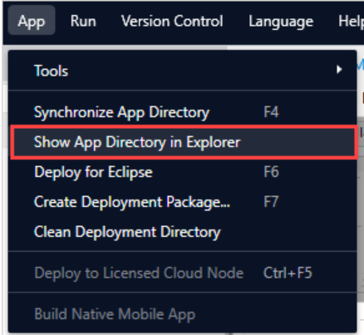

2. Open the **widgets** folder in your app directory and put your Mendix package file there.

3. Open the **App** menu and select **Synchronize App Directory** to synchronize the changes in the app directory:

4. Add your newly imported widget from the ****Toolbox**** or the ****Add Widget**** context menu.

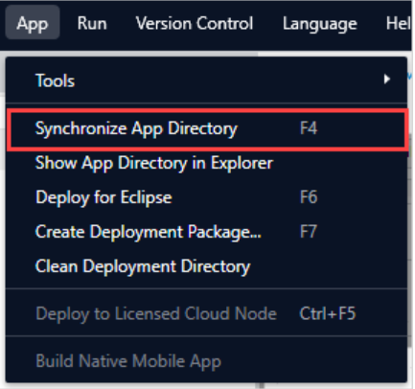

5. After completing the process it will appear in the Widgets Section.

1. **Implementation:**

For your reference if you want to build a pluggable widget then

Go for this module: <https://academy.mendix.com/link/paths/142/Build-a-Pluggable-Widget>

Now to create an expand all functionality I have just implemented this JavaScript code to toggle all the accordions present in the page.

Now to create collapse all functionality used JavaScript code to collapse all the accordions present in the page.

After Creating these two functionalities we need to call this function in a button with onClick event so that our functionality will be executed.

When we click on ‘ExpandAll’ button or ‘>’ Icon then all the accordions present the page will expand similar with collapse all also.

**Full Code:**

**Final Output:**

**Configuration: NA**

**Category: Module**

**Subcategory: All**

**Visibility: Public Marketplace**

**Studio Pro Version: 9.0.5**